Data Analysis Project - Assignment 2
Student Name: Youssef Tarek
ID: 231027091
Task: Analyzing Hospital Patient Data using Python
1. Introduction
In this assignment, I used Python to analyze a hospital dataset. The main goal was to understand patient demographics, identify common health conditions, and calculate how long patients usually stay in the hospital.
2. Data Cleaning (Handling the Mistakes)
Before I could get any results, I had to fix some problems in the data. This is an important step because "dirty data" gives wrong results.
- Fixing Date Errors: I found some rows where the Discharge Date was before the Admission Date. For example, patient PN-7218608 was admitted in March 2025 but discharged 5 days earlier, which is impossible. I wrote code to filter out these rows.
- Missing Information: Some patients didn't have a diagnosis listed. Instead of deleting them, I filled the empty spots with "Unknown" so they wouldn't mess up the count.
- Total Clean Records: After cleaning, I was left with 4,850 valid records to work with.
3. Python Methodology
I used the Pandas library to handle the data. The steps were:
- Converted the date columns into a format Python can understand.
- Calculated a new column called "Stay" (Discharge minus Admission).
- Filtered the data to keep only valid stays (0 days or more).
4. Key Findings & Results
After running my Python script, I found the following:
- Average Patient Age: The average age of patients in this dataset is 47.3 years.
- Hospital Efficiency: On average, patients stay in the hospital for about 5.5 days.
- Most Common Conditions:
  - Urinary Tract Infection (334 cases)
  - Cholelithiasis (325 cases)
  - Atrial Fibrillation (315 cases)
  - Osteoarthritis (313 cases) (Note: There were 338 cases marked as Unknown).
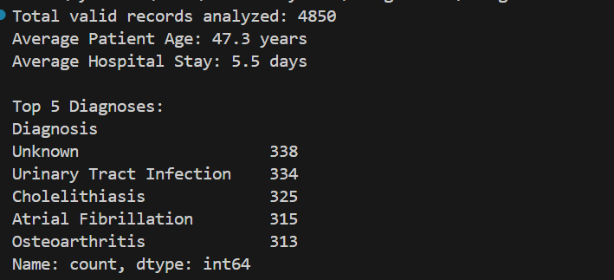
5. Conclusion
Using Python made it easy to find and fix errors in the dates that I wouldn't have noticed manually. The analysis shows that the hospital handles a variety of cases, with an average stay of about 5 and a half days per patient.

